

COLLEGE OF INFORMATICS AND ELECTRONICS

DEPARTMENT OF MATHEMATICS & STATISTICS

END OF SEMESTER ASSESSMENT PAPER

MODULE CODE: MA4005 SEMESTER: Autumn 2006-07

MODULE TITLE: Engineering Maths T1 DURATION OF EXAM: 2.5 hours

LECTURER: J Leahy GRADING SCHEME:
Examination: 100%

EXTERNAL EXAMINER: Prof J King

INSTRUCTIONS TO CANDIDATES
Answer One (1) question from each Section A and B and any three (3) other questions. Five questions in total. All questions carry equal marks.

-2-

MA4005 Engineering Maths T1

SECTION A
Marks

1. a) Find all second order partial derivatives of the following functions
(i) w = x² + xy² + xyz² (ii) z = 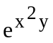 8

b) The area A of a rhombus is calculated using the formula
A = b² sin C
Using the measured values of 4m and 45º for b and C respectively. Find using partial differentiation the maximum error in the area as calculated if there is a maximum error of 0.3cm in the measurement of b and 0.5º in the measurement of C. 12

2. a) Evaluate the integrals
(i) 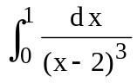 (ii) 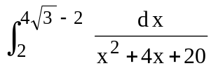 8

b) Find the volume generated when the area between the curve
y = 1 + x³ and the x – axis from x = 0 to x = 1 is rotated about the x-axis. 6

c) Find the moment of inertia about the x – axis of the area in (b). 6

3. a) Find the general solution of each of the differential equations

(i) 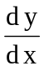 - y sin x = e^{-cos x}

(ii) y" + 2y = t² - 1, 12

b) The vertical motion of a buoy of mass m and cross –sectional area A floating in water of density ρ is given by the equation

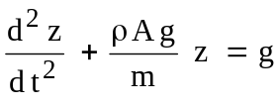 where g> 0 is the gravitational constant.

Express z as a function of t. 8
-3-

MA4005 Engineering Maths T1

Marks

4. a) Calculate, from the definition, the Laplace transform of the function
f(t) = 1 – e^{4 t} 4

b) Use the tables to find the Laplace transform of the functions

(i) f(t) = 3 cosh 4t - 2 sin 2t
(ii) f(t) = t⁴ e^{- 2t} 4

c) Find the inverse Laplace transform of the function

F(s) = 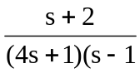. 6

d) Use the Laplace transform to find the solution of the boundary value problem

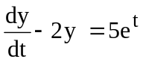 y (o) = 0 6

5. Find the Fourier series of period 2π of the function
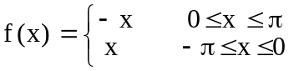 f(x +2 π) = f(x). 16
Use your answer to find an expression for π² 4

-4-

MA4005 Engineering Maths T1
SECTION B

Marks

6. a) Prove (a + b + c) is a factor of the determinant

 3

b) Show the system of linear equations

x – y + z = 2
2x + y – z = 1
4x -y + z = 5
has an infinite number of solutions and find two solutions. 6

c) Find the inverse of the matrix
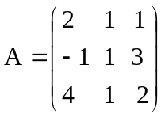 6

and hence solve the system

2x + y + z = 3
-x + y + 3z = - 7
4x + y + 2z = 5 5

7. a) State the axioms for a vector space. 4

b) Show the set of all complex numbers a + bi, a, b ε R, i = 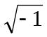, with the usual addition and multiplication by a scalar is a vector space. 6

c) Show the vectors u₁ = (1, 1, 0), u₂ = (2, 0, -3) and u₃ = (0, 1, 5) are linearly independent in R³. 5

d) Determine if the set of vectors

v₁ = (-1, -1, 0)
v₂ = (-1, 0, -1)
v₃ = (0, -1, -1)

span R³ 5

-5-

MA4005 Engineering Maths T1

Marks

8. If 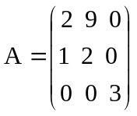 is a matrix find
(i) the eigenvalues of A 7

(ii) the eigenvectors of A corresponding to any one of its eigenvalues. 6

(iii) the rank and mullity of A. 7

